
Design Approval Presentaiton
nIHVA TECHNILOGIES pvt ltd | 187, G-Block, 1st Floor, Thermax Chowk, MIDC, Above Kotak Bank, Chinchwad, Pune - 411019
dESIGN cALCUALTIONS
vAIBHAV MUGALIKAR
2025
Table of Contents
1. Objective 2
2. Technical Details: 2
3. Technical Details: 2
A. Door Construction 2
B. Protective Coating 2
C. Sheet Cladding 2
D. Vision Panel 2
E. Door Movement 2
F. Bottom Tracks 3
G. Top Guide Tracks 3
H. Buffers 3
I. Drive Arrangement 3
J. Electrical Operation 3
K. Manual Operation 3
L. Electrical Control System 3
4. Design Calculation 5
A. Introduction 5
B. Design Requirements 5
C. Calculation :- 5
I. Material selection 5
II. Bearing Selection 5
III. Motor Selection 6
IV. Wind Force On Panels 7

Objective
This document is to prove the design consideration and design calculations are inline with requirements and compient to Indian Standards.

Technical Details:
SNO | Description | Value | Units | Remarks
1 | Door Panels
2 | Clear Opening – Width | 10.3 (total Available 14) | Meters
3 | Clear Opening – Height | 5 | Meters
4 | Each Door Size | 3.70 W x 5.00 H | Meters
5 | Type of Door | Motorized & Multi Leaf
6 | No of Levels | 4 No (4 one side stacking -Either Side)
7 | Door Closing time | 3 min (180 Sec)
8 | Door Cladding | 1 mm
8 | Material Inside door | NA

Technical Details:

Door Construction
The door leaf frames shall be designed to withstand as per required wind speed / wind load. The frames shall be fabricated out of heavy-duty mild steel sections / profiles. The frames shall be of modular design and all sections shall be pre-fabricated at works, ready for assembly at site.

Protective Coating
After fabrication and before transportation all mild steel members shall be cleaned and one coat of primer applied. Before final assembly & installation at site. All bolts, nuts, washers shall be galvanised. Primer and Paint is synthetic enamel ( Two Coat ).

Sheet Cladding
1.0 mm GI sheet.

Vision Panel
No vision provided.

Door Movement
Each door leaf frame shall be supported at the bottom on two (2) load bearing wheels. The wheels are made of steel specially machined to run on bottom rail track. The wheels are fitted with double row sealed ball bearings. All wheels are bolted to the door frame and can be easily removed for maintenance purpose. All the door leaves are guided at the top with three (3) heavy-duty steel ball bearing rollers.

Bottom Tracks
The bottom tracks shall comprise of required runs of steel rails mounted on transverse support and alignment bearers along with fixing bolts etc. The bottom track assembly shall be assembled and aligned at site before grouting. The bottom tracks shall extend up to the extremities of the door-parking bay on one sides of the hangar building.

Top Guide Tracks
The top guides shall comprise of required sets of guide ways mounted on transverse support to the hangar structure. The door support shall be on brackets and dependent on the hangar building. The top guide tracks shall extend up to the extremities of the door-parking bay on both sides. Parking bay is excluded in the quote.

Buffers
Heavy-duty buffers shall be provided at the parking bay extremities of each bottom track. These buffers shall act as emergency mechanical stoppers in case of the doors overshooting their limits.

Drive Arrangement
A 3-phase 415 Volts, AC, 50 Hz electric motor of suitable rating shall drive each master leaf.We shall use helical bevel gear motor which has better efficiency. The drive transmission between the motor and the drive wheel shall be through an efficient gearbox. Each leaf shall be master leaf.

Electrical Operation
The electrical operation of each door section shall be carried out fr om a control panel mounted on the inside of each leaf. The operator shall have to keep the OPEN or CLOSE press button control pressed to enable the door to operate. At each extremity the door section shall automatically STOP, as the control power shall be cut-off through proximity switches. An EMERGENCY STOP BUTTON (STAY-PUT TYPE) shall also be provided on the control panel.

Manual Operation
In case of power failure the doors can be operated manually by disengaging the gearbox and manually operating the gear drive with the handle provided separately. The sequence of manual operation shall be same as the electric operations.

Electrical Control System
General
The electrical control system shall be able to control all aspects of the door movements. The control system for each door section shall consist of a control panel, proximity switches, trailing / bunching cables etc.
Electrical Power Supply
The incoming power supply to the door control panel shall be 415V, 3-phase, 50 Hz, 4 – wire & earth. Power supply to each master leaf shall be by means of a looped trailing / bunching cable system ( Festoon cale carrier system & Conducting ), mounted in the top guide track area from a junction box placed at the top extremities inside the hangar.
Electrical Operation
The electrical operation of each door section shall be carried out from a control panel mounted inside each master leaf. The operator shall have to keep the OPEN / CLOSE push button pressed to enable the door to operate. At each extremity the door shall automatically STOP, as the control power shall be cut-off through proximity switches. An EMERGENCY STOP BUTTON (STAY-PUT TYPE) shall also be provided on the control panel.
Control Panel & System
Each door control panel shall consist of a VFD system mounted on panel, control fuse holders and fuses, indication lamps, interlock contactors, proximity switches, warning lights/hooters, bus bar system on the door after the main in-coming power junction box etc.
Door Operation Safety
The following features shall be incorporated in the control system of the doors:
- The control panel shall be located ( Left / Right ) for easy operation and enable the operator to have a full view of the area during operation of the door.
- The OPEN & CLOSE joy-sticks are constant pressure (HOLD to RUN) and the EMERGENCY STOP push button is STAY PUT type and has to be twisted to release.
- Emergency proximity switch shall be provided at the extreme limits of travel just before the mechanical buffers. These emergency switches shall totally cut-off the control / power supply to the system in case the doors over shoot their normal limits.
- Audio / Visual Alarm – Sliding door control panel ( Inside / outside ) shall be provided with a Flashing Light cum Sounder that shall start & continue to operate during the time the door is in operation.
- Key Operation – An operating key switch shall be provided on each control panel to prevent un-authorised operation of the doors.

Design Calculation

Introduction
This report presents design calculations for the telescopic hanger door system, as per our discussions.

Design Requirements
Door Size :- 3.7 meter (W) X 5 meter (H)
Material :- Steel
Operation :- Motorized
Safety Factors:- 1.5 ( static ) , 2.0 (dynamic )

Calculation

Material selection
Description | Profile | Material | Width/dia (mm) | Length (mm) | Thickness (mm)
Door construction | ISMC 125X65 | Ms | 65 | 125 | 5.3
Top guide track | ISHB100X116 | Ms | 70 | 120 | 4.4
Bottom track | Rail track | Ms
Bottom track wheel | Customized | C45 | Dia 310 |  | 68

Bearing Selection
Given Data
Mass of one door = 1500 kg
Total mass of door m= 1500 x 3 door = 4500 kg
Door Closing distance = 10300mm (10.3M)
Time to Close door = 3 min = 180 sec (as per RFQ)
Travel Speed Reqired + 10.3/180 = 0.057M/min (Approx 3.4M/Min)
Acceleration = 0.1 m/sec²
Acceleration due to gravity = 9.81 m/sec²
Coefficient of friction = 0.01= µ

Dynamic Load Calculation
F_{D} = µ x m x g + m x v
= 4500*0.01*9.81+4500*0.058
= 702.450 N (0.702 kN)

Static Load Calculation
LS) = DEAD LOAD + LIVE LOAD
But in that case there is no live load so live load is zero,
Dead load is 1500 kg so ,
= 4500 + 0
= 44145 N (44.145kN)
Bearing Selection
No of Wheels 8 nos
No of bearing in each wheel 2 nos
Total no of Bearings 16 Nos

According to static load and dynamic load factor below bearing no is sutaible
MAKE – SKF
EARING PART NO – NJ 308 ECP
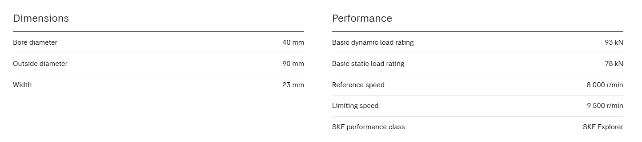

Motor Selection
Given data :
Mass of one door = 1500 kg
Total mass of door = 1500 x 3 door = 4500 kg
Door Closing distance = 10300mm (10.3M)
Time to Close door = 3 min = 180 sec (as per RFQ)
Travel Speed Reqired + 10.3/180 = 0.057M/min (Approx 3.4M/Min)
Acceleration = 0.1 m/sec²
Acceleration due to gravity = 9.81 m/sec²
Coefficient of friction = 0.01 = µ
Calculate output speed (n) rpm :
Speed of the Door = 3.4 M/min
Dia of the Roller OD = 310 mm Dia = 0.31 M
Circumfrence = 3.14 x D = 3.14*0.31 = 0.9739 M
RPM at door wheel = 3.4/0.9739 = 3.49 RPM = ~ 3.5 RPM

Calculate Torque
T = Total force X Wheel radius
Total force = 702.450 N
Wheel radius = 155 mm = 0.155 m
= 702.450 *0.155 = 108.879 N-m = ~110 N-m
Calculate power :
POWER = 2*π*N*T / 60 Watts
= 2*3.14*3.5*110/(60*0.7) =57.595 W = ~0.057 kW

Motor Selected From Catalogue
NORD MOTOR
A Sereis (Helical Bevel Gear Motor)
PART NO - SK9032.1-100LP/4 BRE20 HL TF
RPM – 27 ; Torque – 527 N-M (860 N-m); SF-1.6; Ratio 52.02

Wind Force On Panels
Geological study at client side: -
client location - Aluva Kerala
wind speed - 39 m/sec
Temperature – 420C
Humidity – 98.1 %
Air density – 1.2 kg/m³
Wind pressure: -
P=0.6 $×$ $V^{2}$ – as per IS 875 - Part3
P=0.6*39²
P=912.6 Pa

Wind load: -
F= P x A
A = Area of door leaf
= 3.7 x 5
=18.5 m²

F =P x A
= 912.6x18.5
= 16883.1 N
Consider factor of safety is 2
So, wind load = 16883.1 x 2
Wind load per door = 33766.2 N

Reaction of Door
Total Area 3.7 x 5 meters
Pressure 912.6 N/m^2
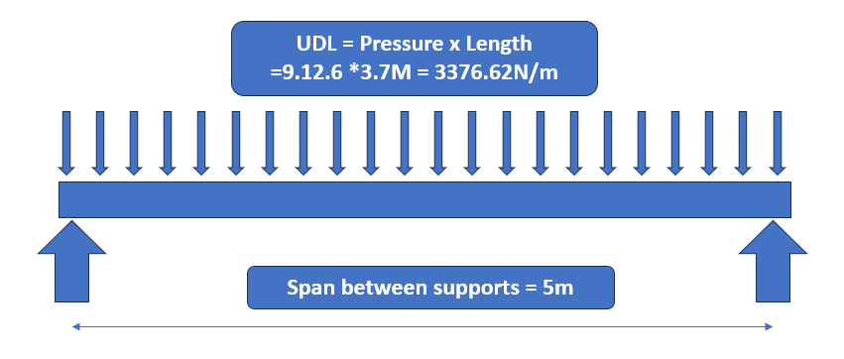
Total Area 3.7 x 5 meters
Pressure 912.6 N/m^2

Ra = wL/2 and Rb = wL/2
Ra = Rb = wL/2 = 3376.62N/m *5 / 2 = 8441.55N (860.5 Kg)

Guide Roller bearings
Roller QTY per door = 6 Nos

Load on each roller = 8441.55 / 6 = 1406.925 N

Bearing Selected is 6203zz – ID 17 x OD 40 x 12 THK 

